XPATH

Is a language to quert xml document.

It consists of path expression and some condition

Xpath can be

Absolute : starts with / . and always starts with the root node

Relative : starts with // . And it can start with any element in the middle of the doc (downward

Xpath = /tagname[@attribute=’value’]

Xpath =/input[@id=’a’]

Whatsapp xpath

//span[@class="ggj6brxn gfz4du6o r7fjleex g0rxnol2 lhj4utae le5p0ye3 l7jjieqr i0jNr" and @title="Raghu Bandi"]

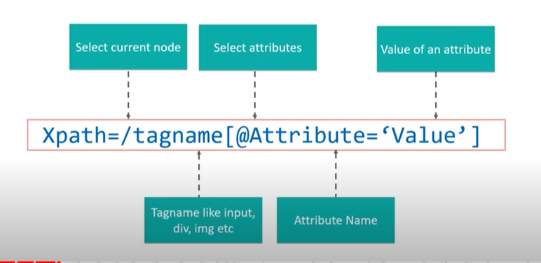

**Xpath functions**

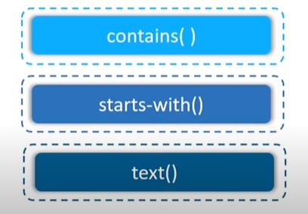

Xpath = //*[contains (@type ,’value’)]

Example

//img[contains(@src, 'blueheaven')]

Xpath = //htmltag[starts-with (@id , ‘message’)]

//img[starts-with(@alt,'Women Cl')]

//*[starts-with(@class, 'a-touch-link')]

OR operation (|)

//input[@name='username'] | //input[@id='login-username']

Note

//a 🡪 five all the href links

//* 🡪 give all the elements

Driver commands

|  |
| --- |
| System.setProperty(“webdriver.chrome.driver”,”path.exe);” |
| WebDriver driver = new ChromeDriver(); |
| driver.get(“URL”) |
| driver.close(0; |
| driver.quit(); |
| driver.manage().window().maximize(); |
| driver.manage().window,minimize() |
| driver.manage.deleteAllCookies()  driver.manage().timeouts().pageLoadTimeouts(30, TimeUnist.Seconds) |
| |  | | --- | |  | |  |   driver.manage().timeouts().implicitlyWait(30, TimeUnist.Seconds) |
| driver.manage().window().maximise()  driver.manage().window().minimise()  driver.manage().window().getSize()  driver.manage().window().setSize()  driver.manage().window().getPosition  driver.manage().window().setPosition  (JavaScriptExecutor)driver.executeScript(“window.resize(x,y)”) |
|  |
| driver.navigate().back();  driver.navigate.forward() |
| driver.navigate.defaultContent();  driver.findElement(By.id(“id”)) |
|  |
|  |
|  |
|  |
| driver.getTitle() : title of the page |
|  |
|  |
|  |
| To scroll down  javaScriptExecutor js = (javaScriptExecutor) driver;  js.executeScript(“window.scrollBy(0, 300)”) |
|  |
| driver.findElement(Bt.xpath(“//input[@name='username'] | //input[@id='login-username']”) |
|  |
| driver.switchTo()  Alert alert = driver.switchTo().alert(); |
| alert.dismiss() |
| alert.accept() |
| alert.cancel() |
| alert.getText(); |
|  |
| Robot robot = new Robot();  robot.mouseMove(400,5)  robot.mousePress(InputEvent.BUTTON1_DOWN_MASK)  robot.mouseRelease(InputEvent.BUTTON1_DOWN_MASK) |
| driver.switchTo().frame() |
| driver.switchTo().window()  driver.switchTo().alert() |
|  |
|  |
|  |
|  |
|  |
|  |
|  |
|  |
| Assert.assertEquals(actualtile,expectedTitle) |
| Assert.assertTrue(True) |
|  |
|  |

End of table

|  |
| --- |
|  |
|  |
|  |
|  |
|  |
|  |
|  |
|  |

**JavaScriptExecutor :** is a interface that helps to execute javascript through selenium webdriver

**JavaScriptExecutor Methods**

1. **executeAsyncScript**
2. **executeScript**

**Driver commands**

|  |
| --- |
| driver.close(); |
| driver.equals(devTools) |
| driver.findElement(null) |
| driver.findElements(null) |
| driver.get(null) |
| driver.getClass() |
| driver.getCurrentUrl() |
| driver.getPageSource() |
| driver.getTitle() |
| driver.getWindowHandle() |
| driver.getWindowHandles() |
| driver.hashCode() |
| driver.manage() |
| driver.navigate() |
| driver.notify() |
| driver.notifyAll() |
| driver.quit() |
| driver.switchTo() |
| driver.toString() |
| driver.wait() |

**Selenium Framework**

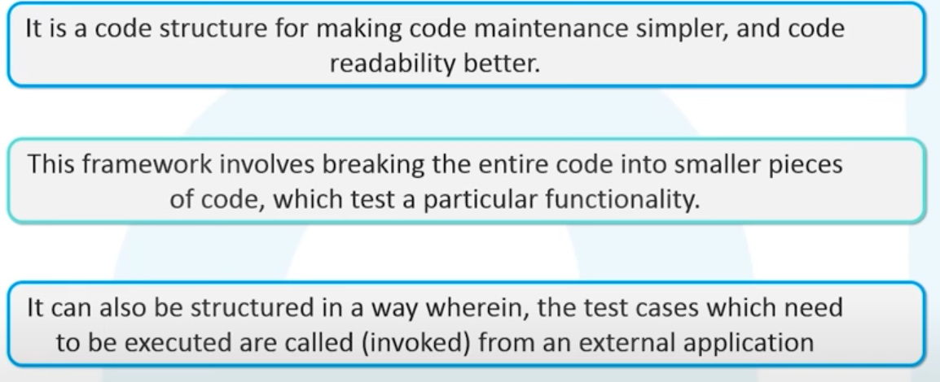

**LOCATORS**

CSS Selector Loacator

Format css = #HTML tag.class[atribute= value]

Xpath : //tagname[@attribite=value]

**JavaScrptExecutor**

Is a interface between selenium webdriver and the UI interface

**Waits in Selenium**

Implicit wait

Explicit waits

**Implicit Wait**

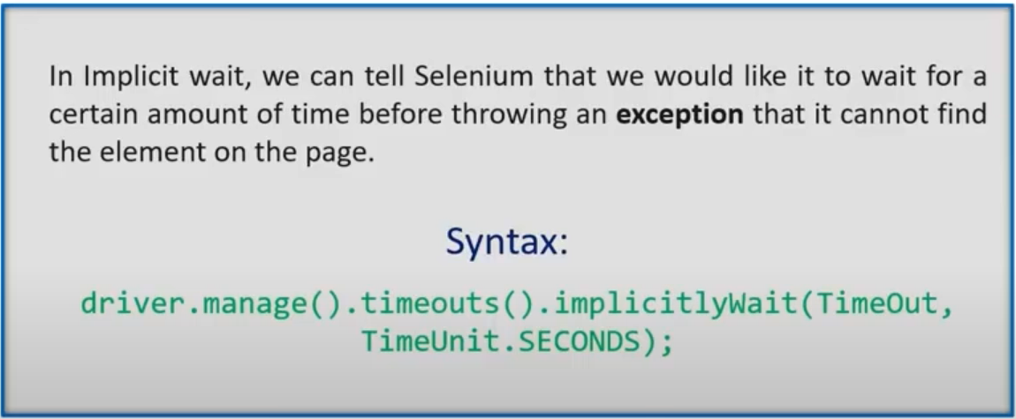

**Explicit wait**

|  |
| --- |
| WebDriverWait mywait = new WebDriverWait(driver,10000);  WebElement username = mywait.until(ExpectedConditions.visibilityOfElementLocated(By.xpath("//*[@id=\"RESULT_TextField-1\"]")));  username.sendKeys("NEW NAME");    WebElement pwd = mywait.until(ExpectedConditions.visibilityOfElementLocated(By.xpath("//*[@id=\"RESULT_TextField-2\"]")));  pwd.sendKeys("MY NEW PASSWORD"); |

|  |
| --- |
| WebElement fname= driver.findElement(By.xpath("//*[@id=\"RESULT_TextField-2\"]")  WebElement lname= driver.findElement(By.xpath("//*[@id=\"RESULT_TextField-2\"]")  explicitWaitSendKeys(driver, fname, 10,'MyValue')  explicitWaitSendKeys(driver, lname, 30,'MyValue')  public static void explicitWaitSendKeys(WebDriver driver1, WebElement element, int timeout, String value){  new WebDriverWait(driver1, timeout).until(ExpectedConditions.visibilityOf(lement ));  element.senKeys(value);  } |

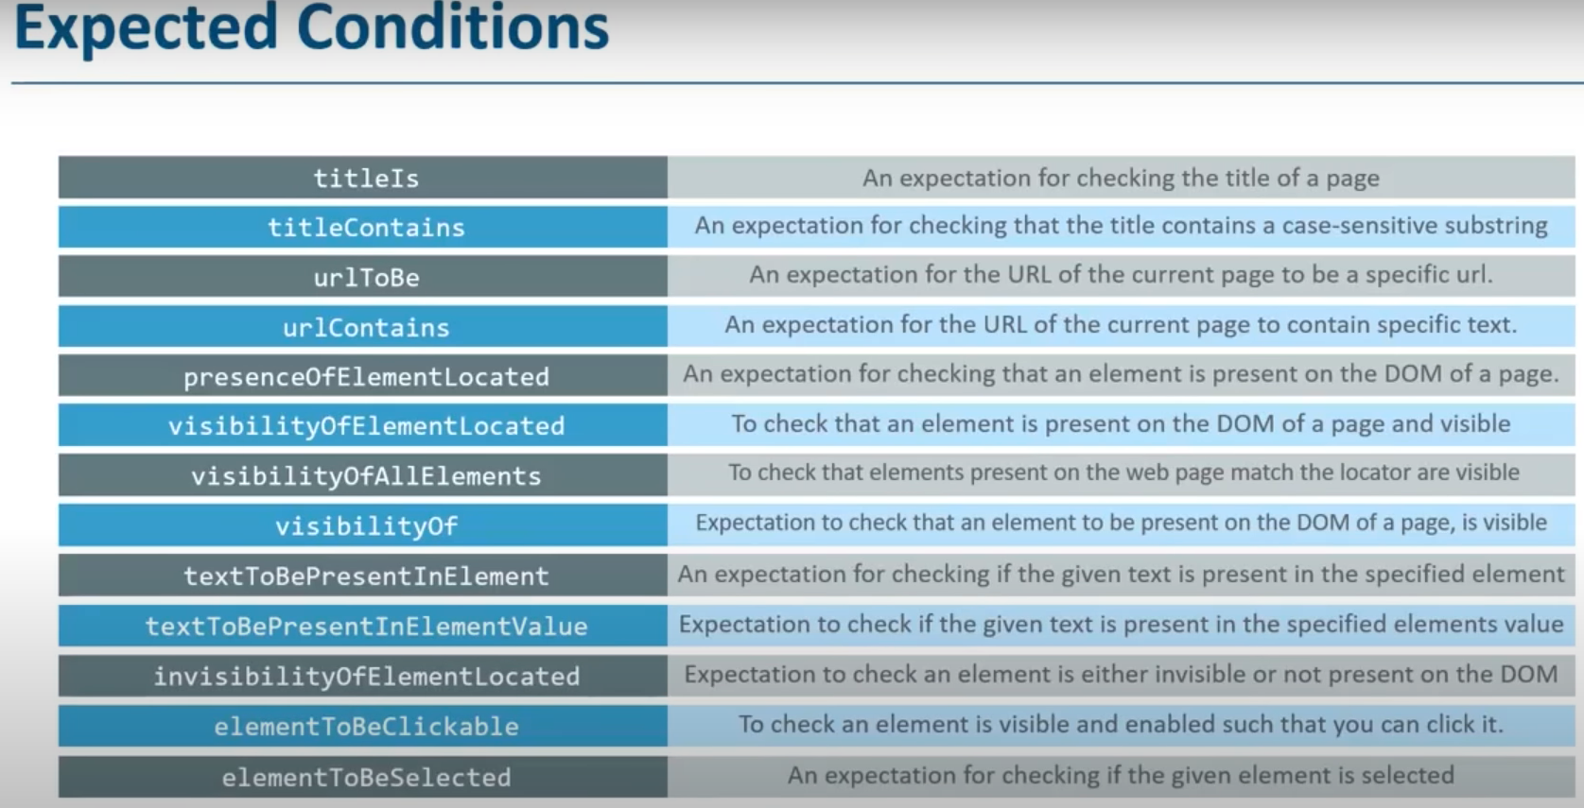

Implicit wait is applied to all the elements in the page. No condition is specified

Explicit wait is applied only on those element that are mentioned in the scripts. Condition is specified

**Fluent wait**

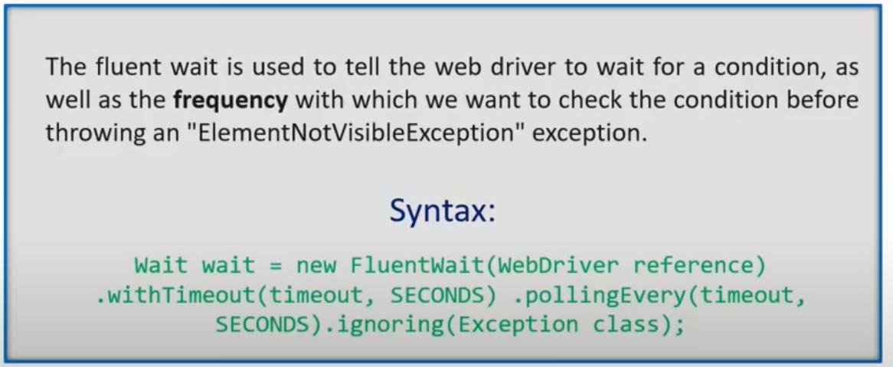

PopUps: Selenium cannot handle popup windows. Pop ups are handled using alert interface.

**Alerts:**

Alerts are popup windows that takes the focus from current window and passes control to the popup window.

Types

Simple alert : warning

Prompt alert : asks for input

Confirmation alert: asks for permission

driver.switchTo()

Alert alert = driver.switchTo().alert();

alert.dismiss()

alert.accept()

alert.cancel()

alert.getText();

**Robot** : class used to handle keyboard and mouse action

|  |
| --- |
| Robot robot = new Robot();  robot.mouseMove(400,5)  robot.mousePress(InputEvent.BUTTON1_DOWN_MASK)  robot.mouseRelease(InputEvent.BUTTON1_DOWN_MASK)  robot.mouseMove();  robot.mousePress |

It is similar to Action class. But also provides more functionality like uploading a file and also handles pop ups as well.

**Exception**

Is a event that disrupts the normal flow of a program

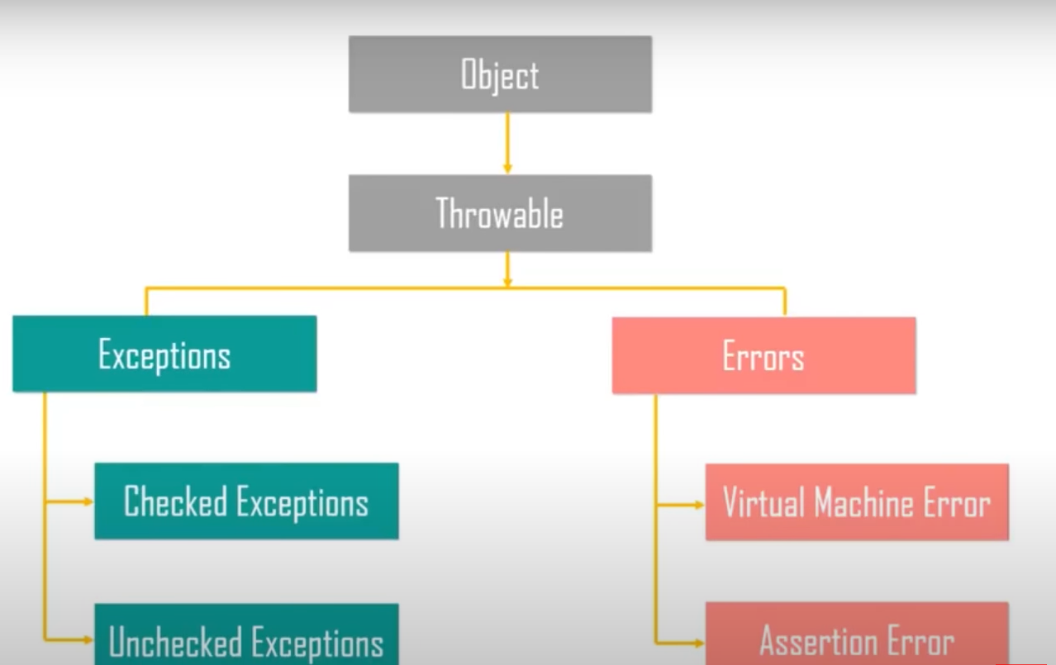

Checked exception: are checked by the compiler at compile time

Unchecked exception: occur during the runtime

Types

WebDriverException

NosuchElementException

NoSuchFrameException

NoAlertException

TimeoutException

Methods

Try

catch

throw

throws

finally

**How do you achieve synchronization in webdriver**

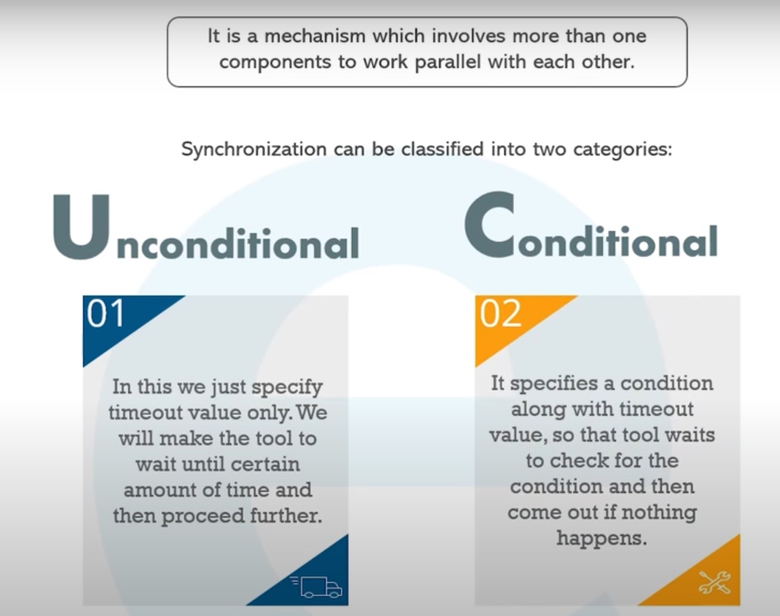

**Listeners**

Listeners are interface used in selenium webdriver that listens to an avent and performs an action.

Listens to an event and behave accordingly.

**Types of listeners**

**WebDriver Listeners**

🡪WebDriverEventListener🡪catches webdriver events

🡪EventFiringWebDriver

**Testng Listners**

**Different type of testNG Listener**

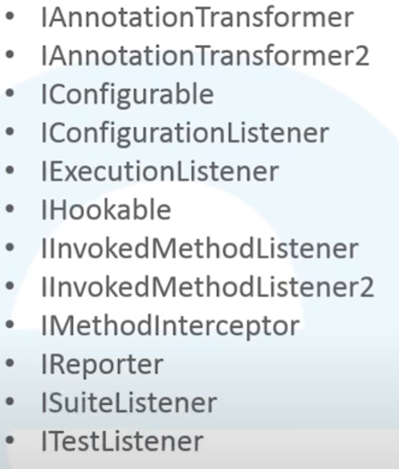

**Methods in ITestListener**

onStart

onFinish

onTestFailedButWithinSuccessPercentage

onTestFailure

onTestSkipped

onTestStart

onTestSuccess

**In the implementation class**

@Listeners(ListenerTest_Class.class)

Testng: Is a automation testing framework in which NG stands for next generation

Features of TestNG

Support for annotation

Data driventesting

Ability to reexecute the failed test cases.

Flexible test configration

Priority setting and specift the execution order

Grouping the test case

Annotation : is a piece of code that used to control the flow of methods.

Testng Annotation

@BeforeSuite

@BeforeClass

@BeforeTest

@BeforeMethos

@Test

@AfterSuite

@AfterClass

@AfterMethod

@AfterTest

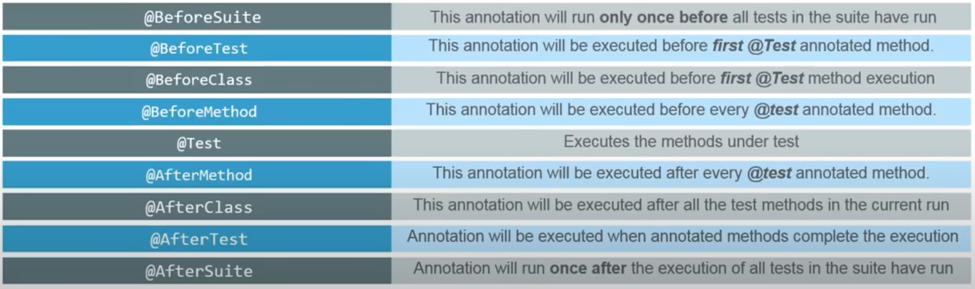

Creating Testng Project

Create new Testng Project

Configure build path and testng library

Create ne testng class file

Code the program and run the testng suite

Use annotation

Cross browser testing

@Parameters(“browser”)

Testng.xml

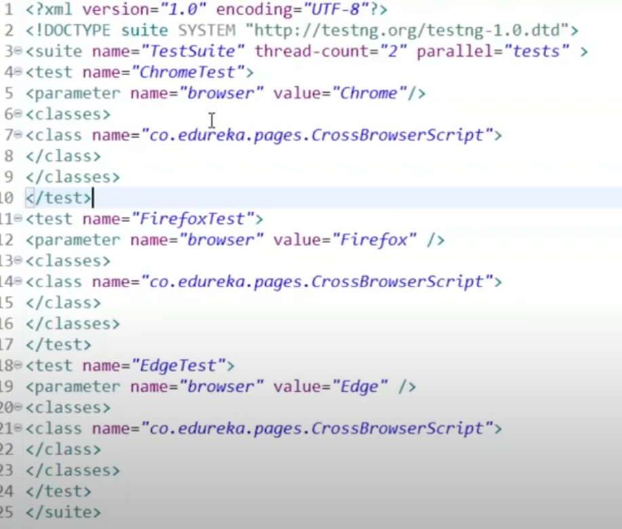

**Action class:**

Is a built-in ability to handle keyboard and mouse events

**Methods for keyboard interface**

Sendkeys() : send some keystrokes to the element

keyUp() : used to send keypress event without a release

keydown() : helps in releasing the key

**Methods for mouse interface**

Click()

doubleClick()

contextClick() : performs right click action on mouse

dragAndDrop(): invoke clickAndHold at source and moves to the target without releasing the mouse

clickAndHold() : clicks at the current mouse location without realising it

dragAndDropBy(): clicks and hold at the source loc and shifts according the the given offset horizontally or vertically ( x, y)

moveByOffset():

moveToElement()

release();

There are two classes

Action

Actions

Difference between Action and Actions class in Selenium Actions is a class that based on a builder design pattern. This is a user-facing API for emulating complex user gestures. Whereas Action is an Interface which represents a single user-interaction action.

Actions act = new Actions(driver);

WebElement element= driver.findElement();

act.moveToElement(element).build().perform()

act.dragAndDrop(source, target).build.perform();

Actions builder = new Actions(driver);

WebElement act= driver.findElement();

WebElement search= driver.findElement();

Action seriesOfAction;

seriesOfAction = builder

.sendKeys(act , “Selenium”)

.keyDown(search, keys.SHIFT)

.keyUp(search, keys.SHIFT).build().perform();

**For drag and drop**

Actions act= new Actions(driver);

act.dragAndDrop(source, target).build.perform();

or

act.clickAndHols(source).moveToElement(target).release().build().perform();

**Robot class**

Provides control over mouse and keyboard sevices.

Importance of robot class

Uploading a file

Handles the pop ups

Handles mouse and keyboard events

Methods in robot class

keyPress()

keyRelease()

mousePress()

mouseRealease()

mouseMove()

Ex

Robot robot = new Robot();

robot.keyPress(KeyEvent.VK_DOWN);

robot.keyPress(KeyEvent.VK_TAB);

robot.mouseMove(x, y);

Limitation

Mouse/keyboard works on current window

It is difficult to switch between different frames and windows

mouseMove() sepends on screen resolution. If you are running and virtual machies the chances of failure is high.

Selenium: Is a automation tool to test web application. It is open source. And is used to automate on various browsers.

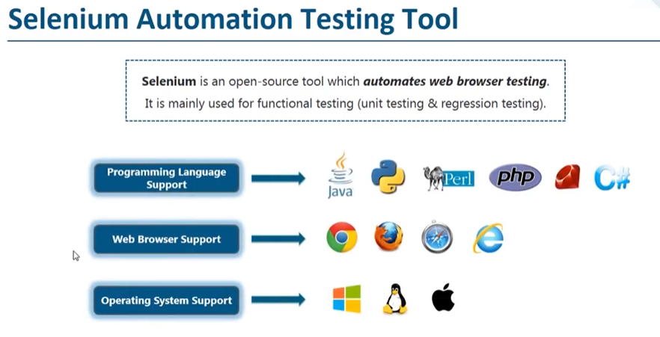

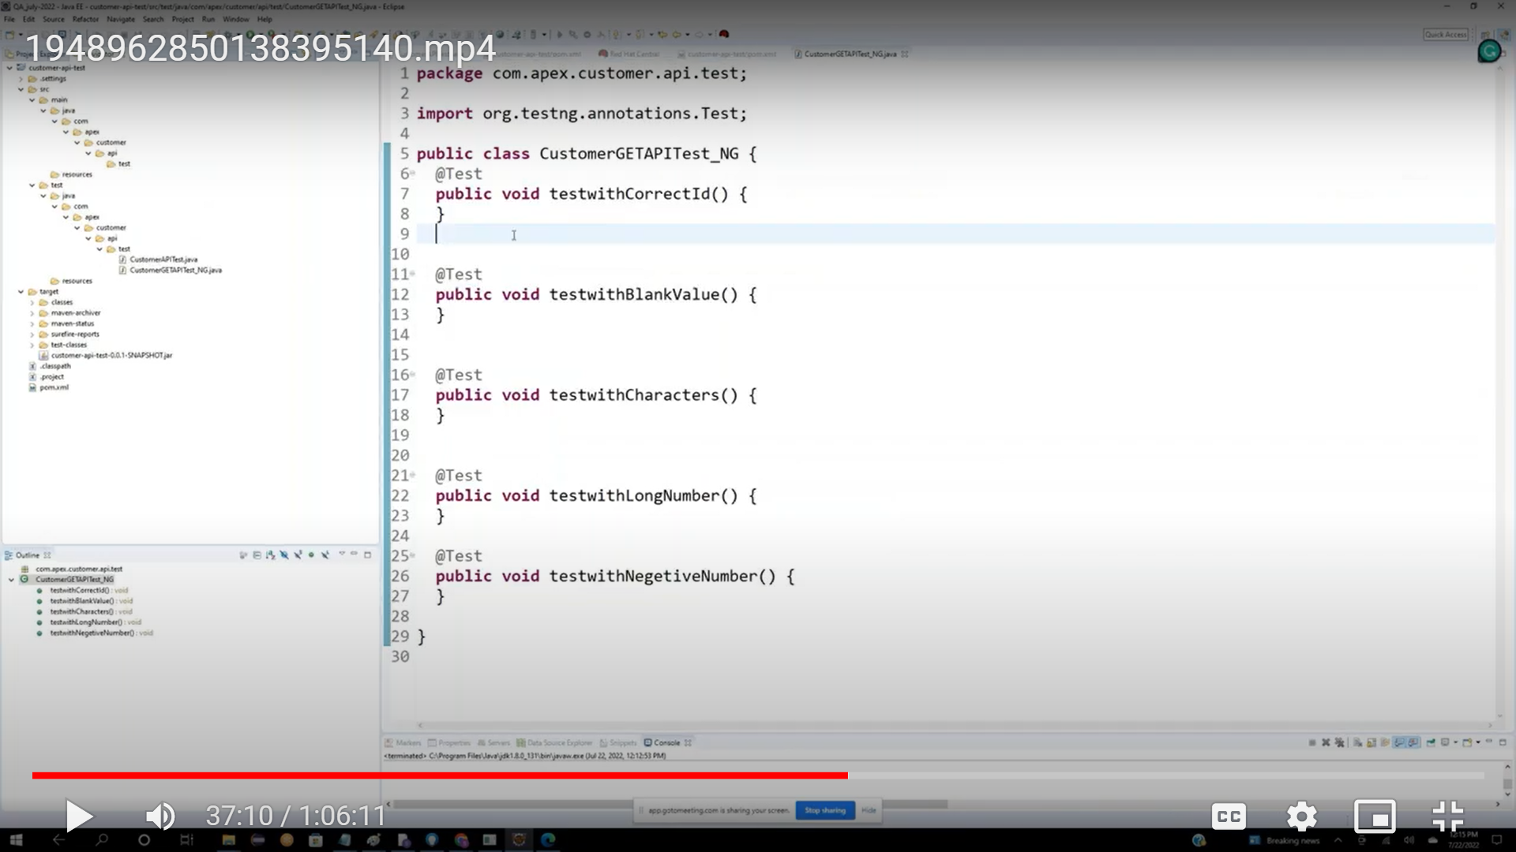

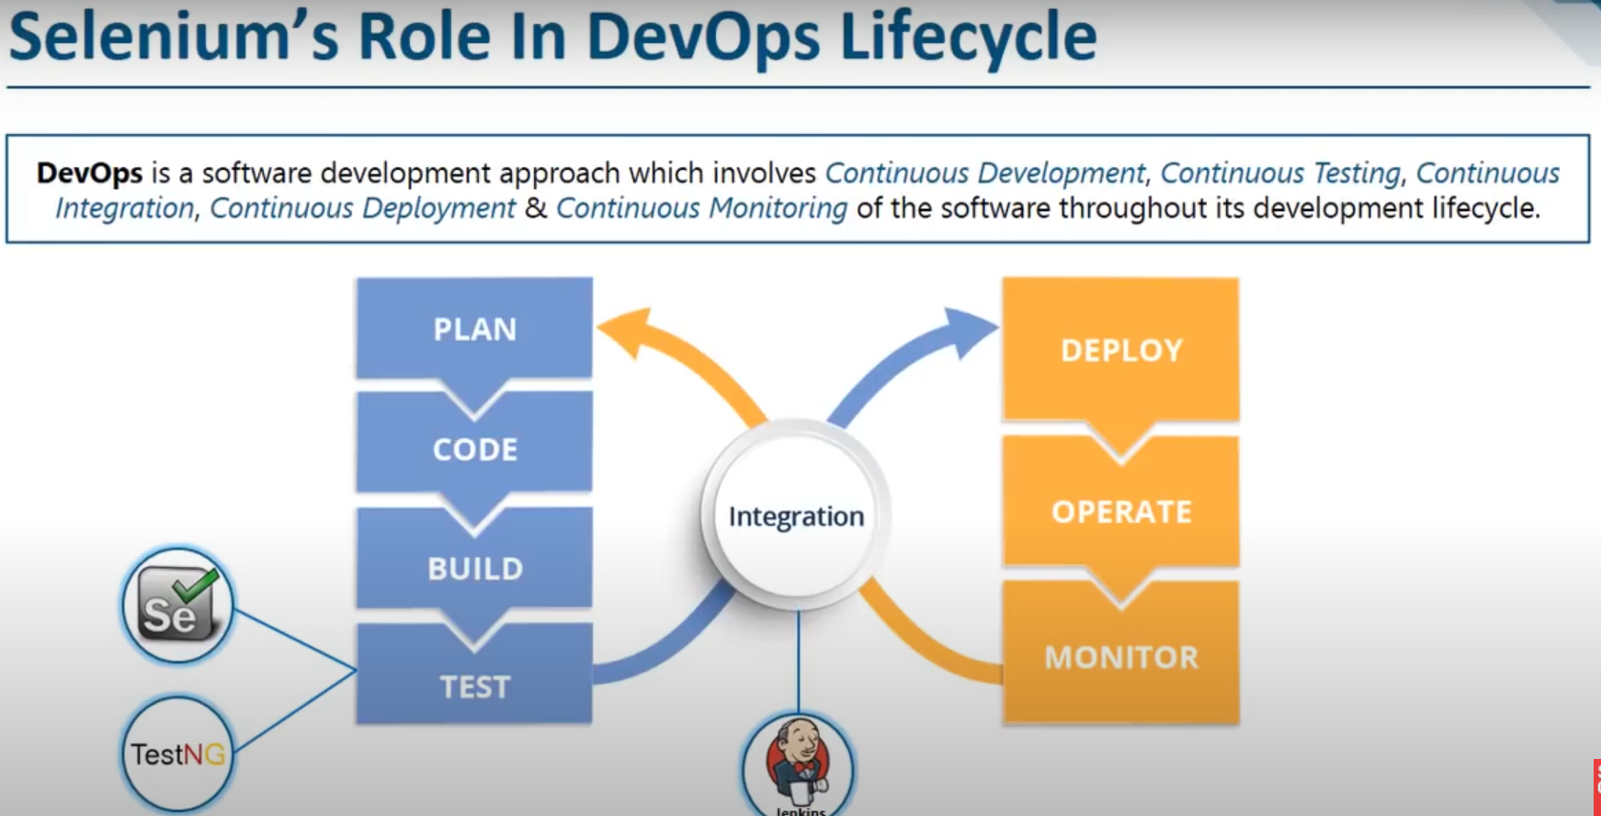

**Selenese**

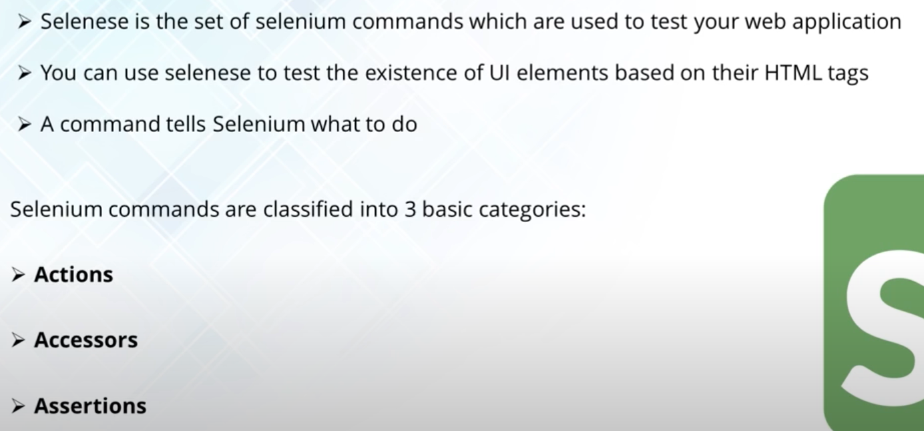

Selenium Grid

Good video for selenium grid

<https://www.youtube.com/watch?v=FRn5J31eAMw&t=18786s&ab_channel=edureka%21>

@ [5:44:21](https://www.youtube.com/watch?v=FRn5J31eAMw&t=20661s) Selenium Grid tutorial

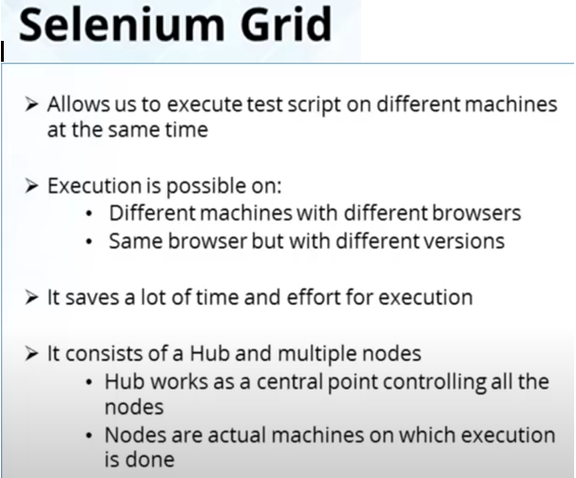

**Start the hub and Node**

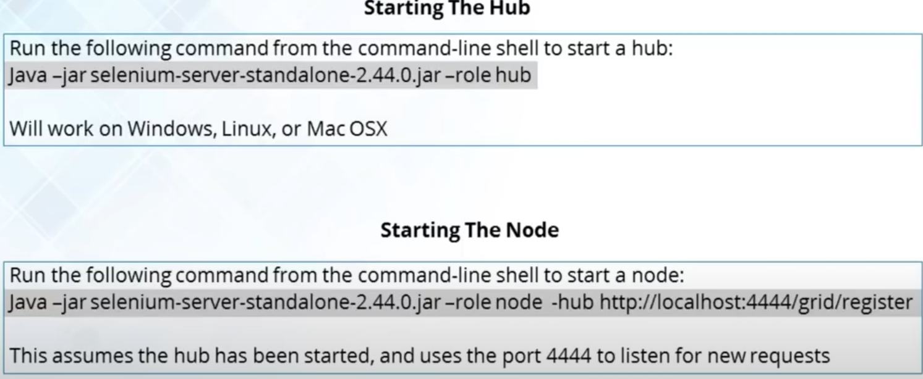

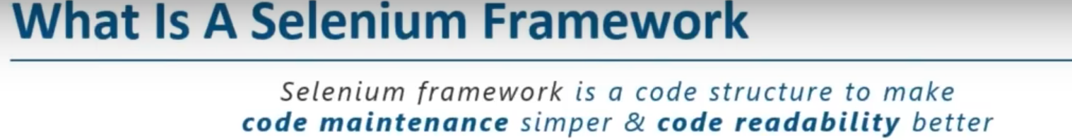



Types of framework

* Data driven framework
* Keyword driven framework
* Hybrid framework

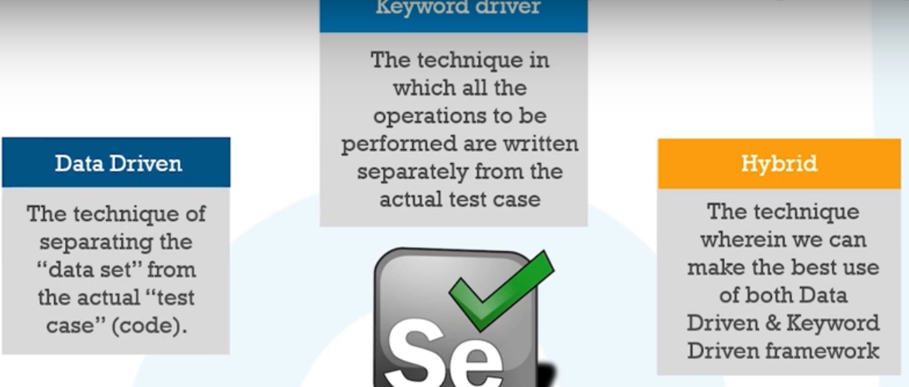

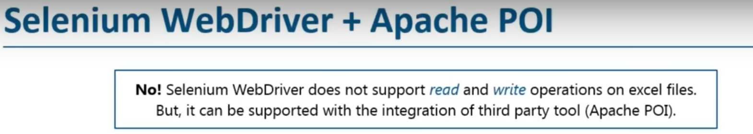

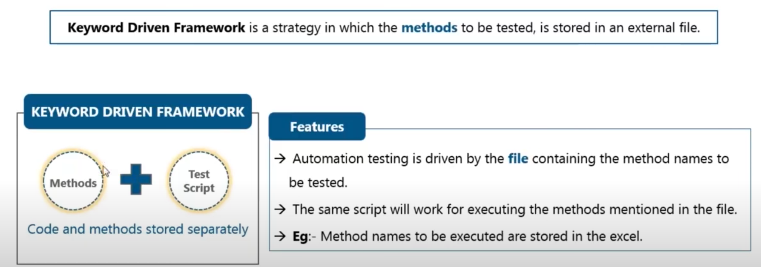

**Cucumber**

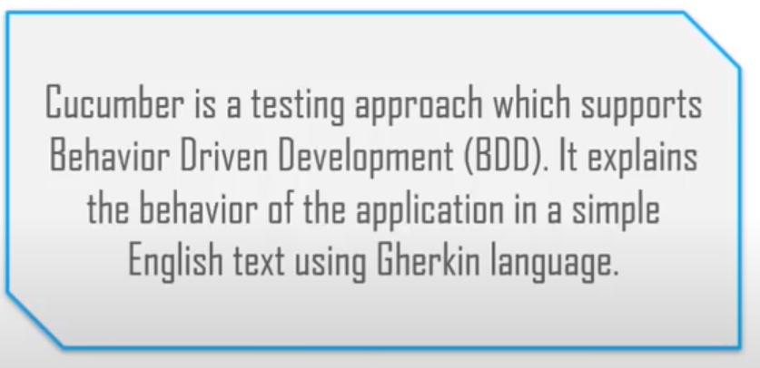

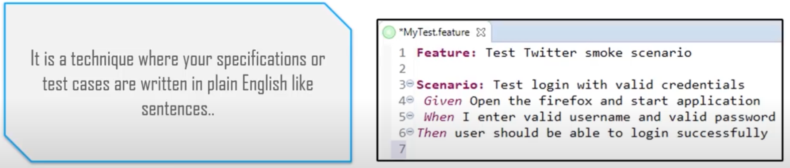

Prerequisites for cucumber

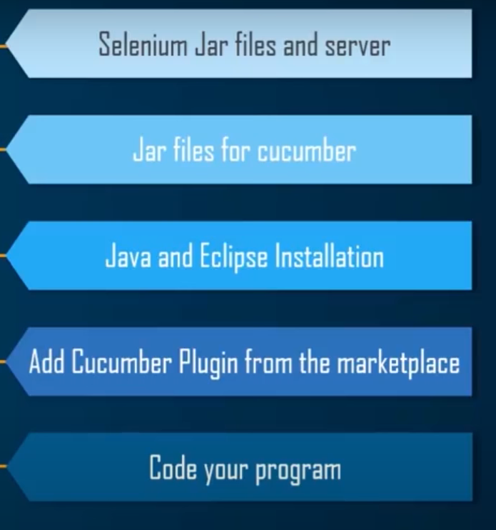

Steps to create cucumber application

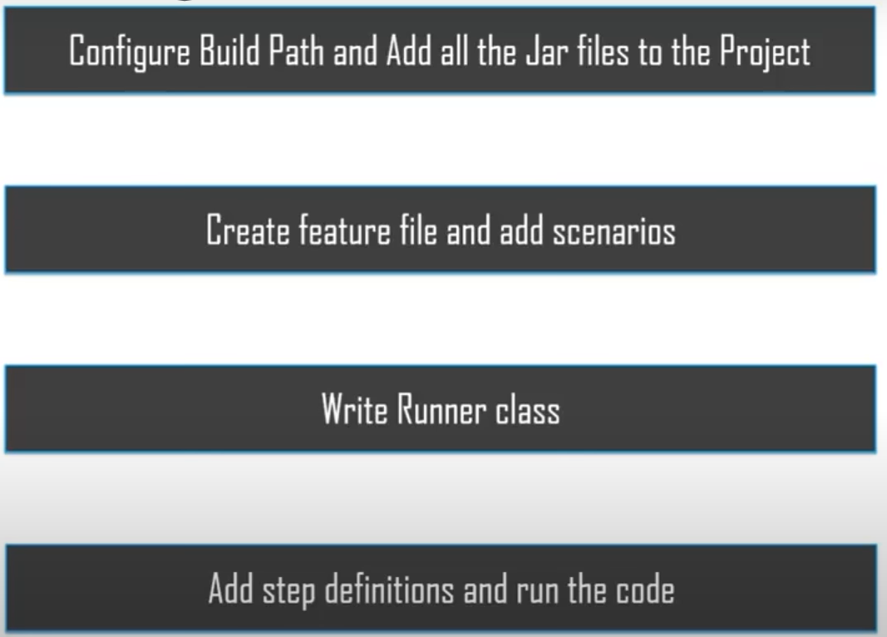

**Page Object Model**

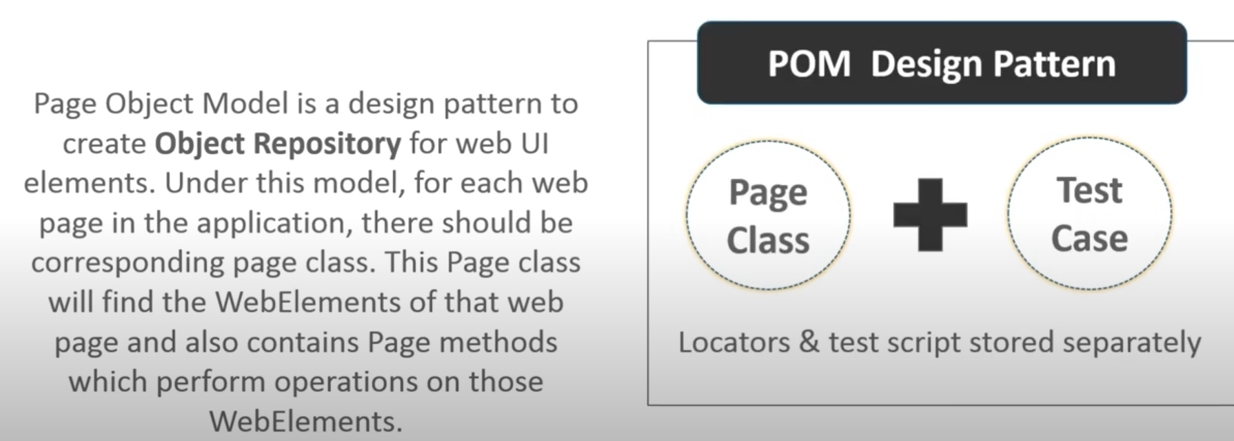

**Advantages of page object model**

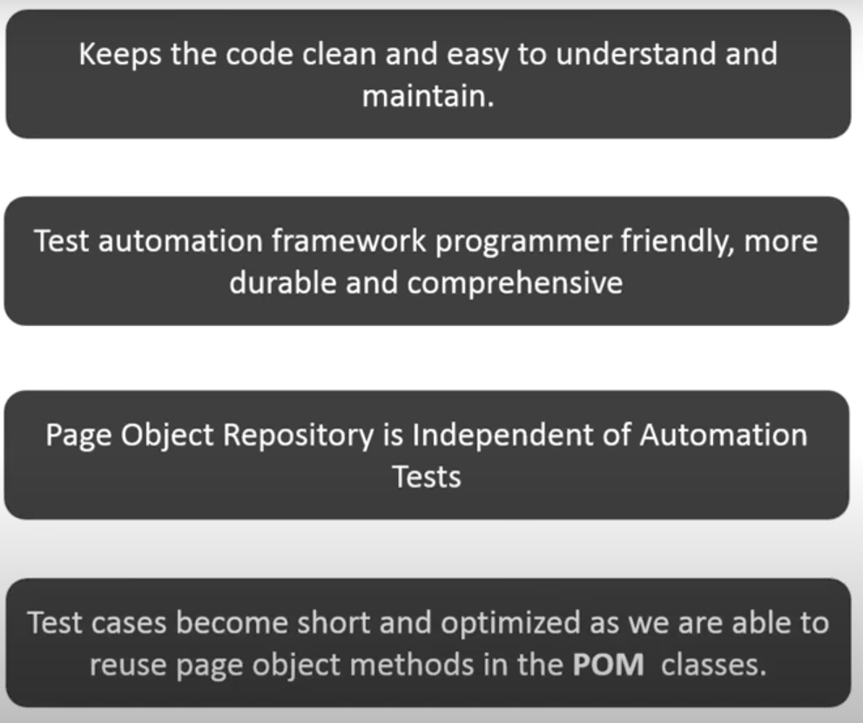

Page Factory

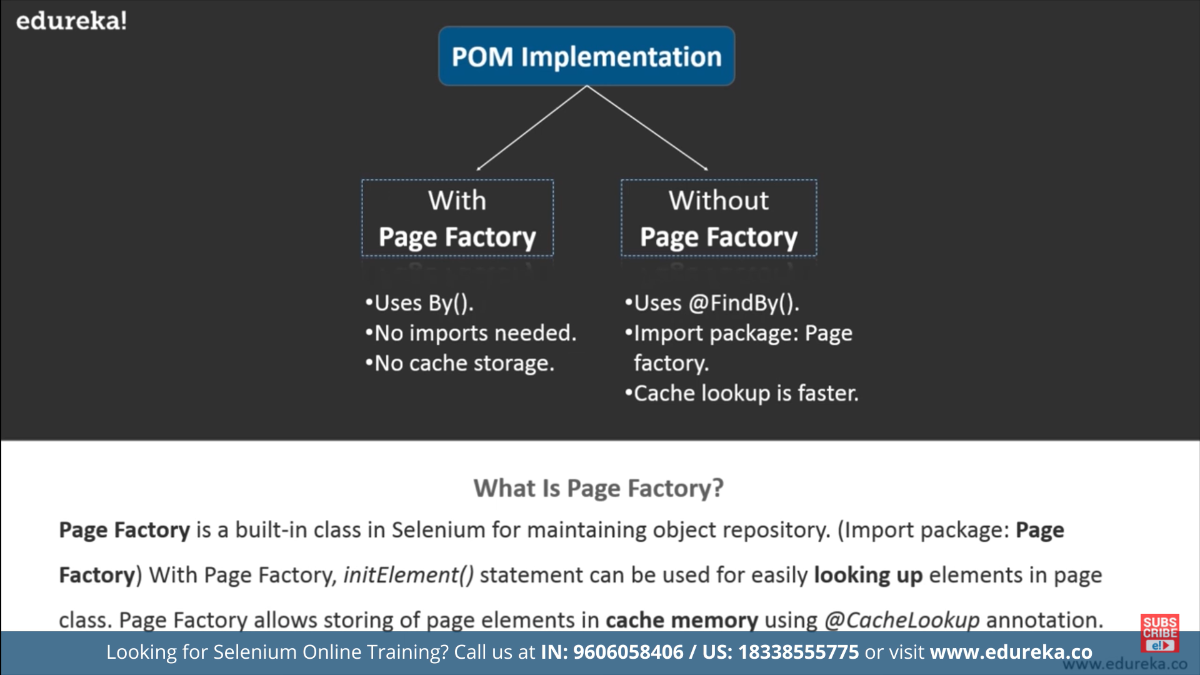

**POM structure**

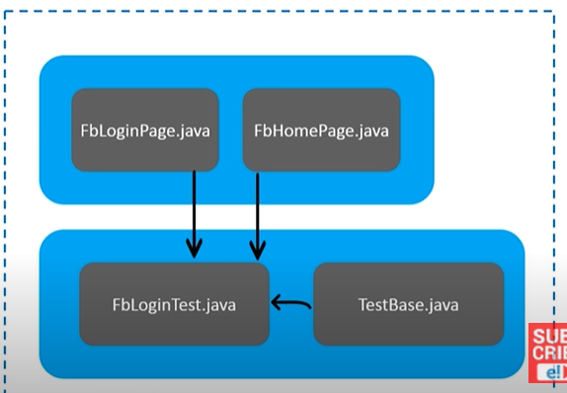

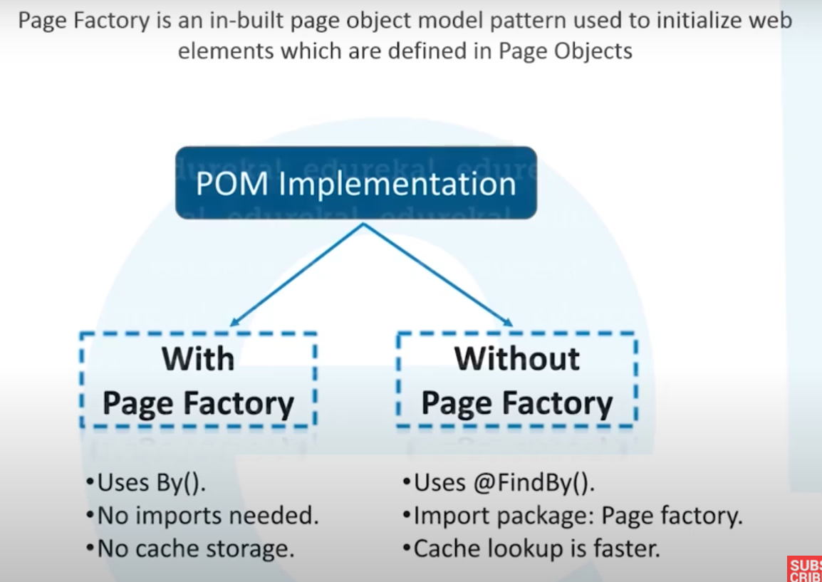

**Difference between POM and Page factory**

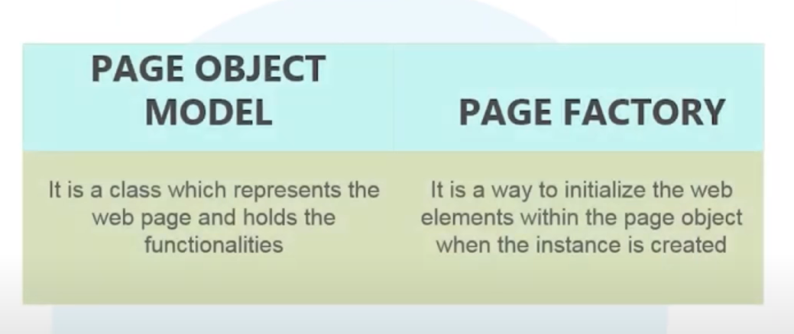

Driver methods

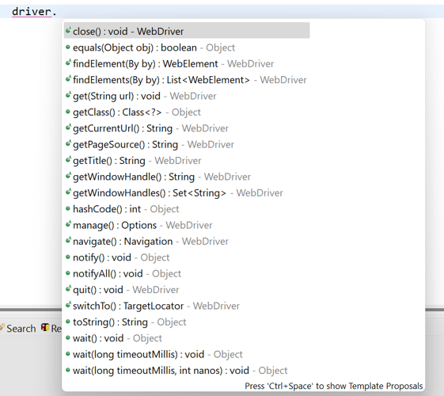

**Screenshot**

How to take screenshot in selenium

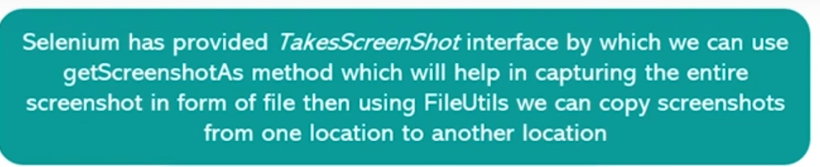

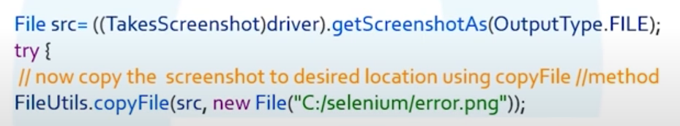

**Window handle**

How to handle multiple windows in slenium

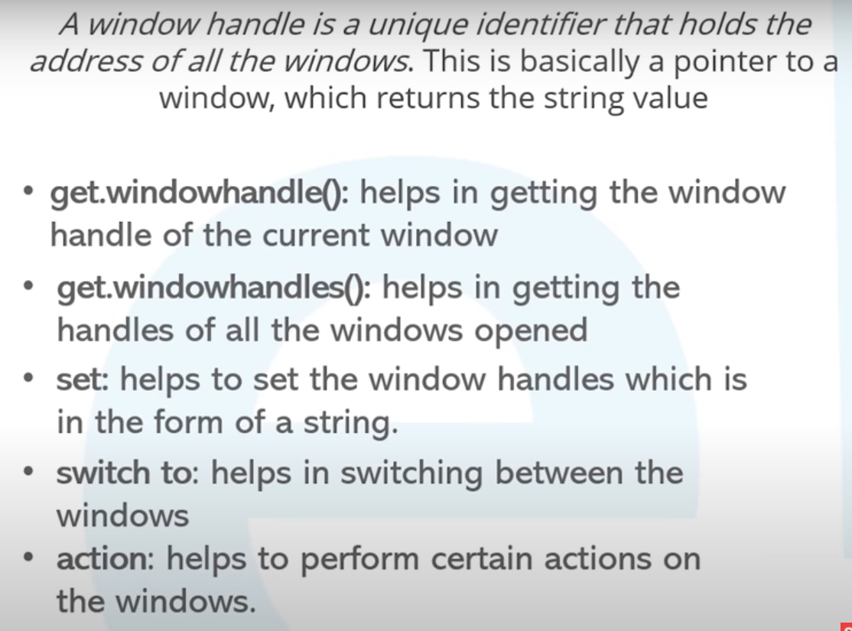

Assert

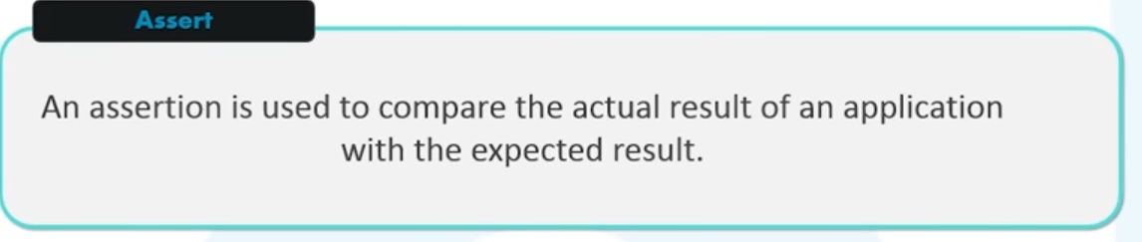

Verify

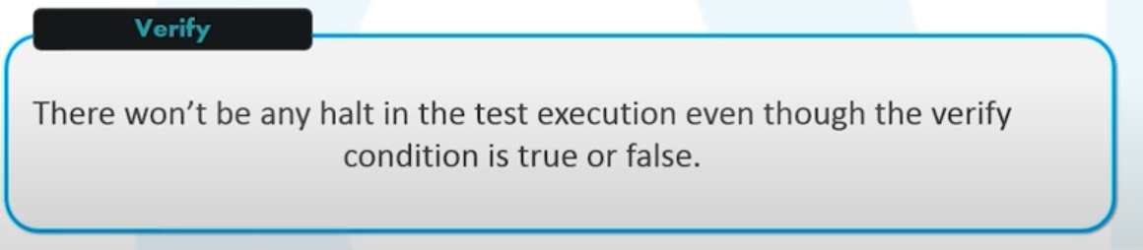

**Proxy**

How to redirect from browsing to browser through proxy

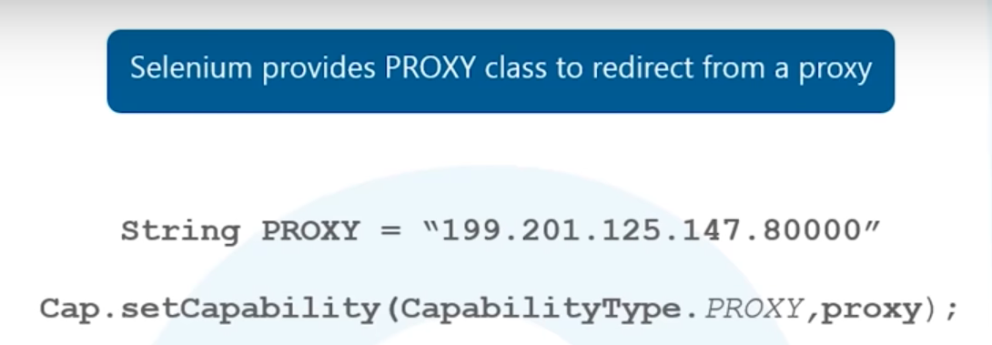

**Network Latency**

How do you handle network latency

Driver.manage.pageLoadingTime();

Server side log

How to capture Server side log in selenium

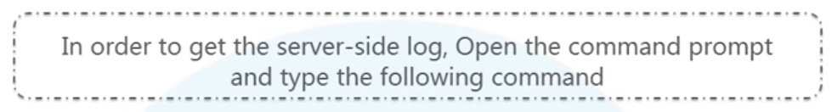

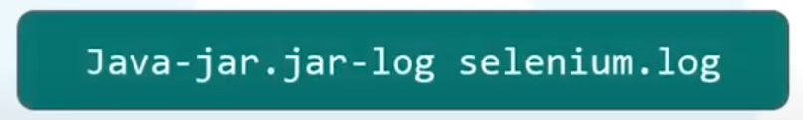

Database Testing

How can you achieve Database Testing using selenium

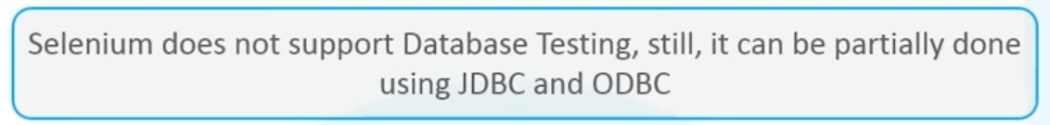

Session handling

**Difference between Selenium and QTP**

Browser compatibility

Distribution: open source, vs licenced

Application under test : selenium test web bassed app, qtp support web app , mobile and desktop

Lang support: selenium support: java, ruby , python, c#. QTP supports VBscript

Vendoe support: no Vendoe support for selenium, QTP has Vendoe support

SetSpeed vs Thread.sleep



()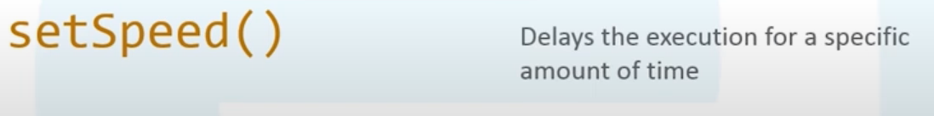

**How to submit a form in selenium**

Webelement.click();

Webdriver APIs

HTML Unit driver

chromeDriver

firefoxDriver

edgeDriver

OperaDriver

HTML unit driver is the fastest as it is headless (does not execute in the browser)

Navigate or navigation back and forth in the webpage

driver.navigate.forward();

driver.navigate.bavk()

driver.navigate.refresh()

driver.navigate.to(“url”)

**Why do you prefer selenium**

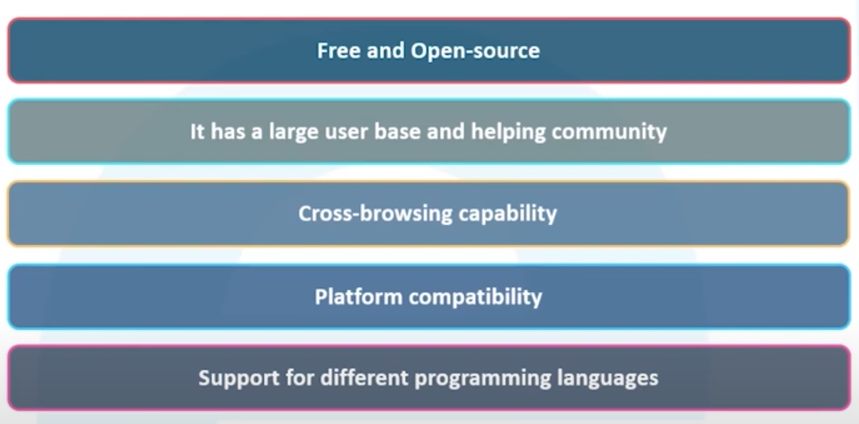

Resume

Job description requirement

